**Starbucks: Using Big Data, Analytics And Artificial Intelligence(NN) To Boost Performance**

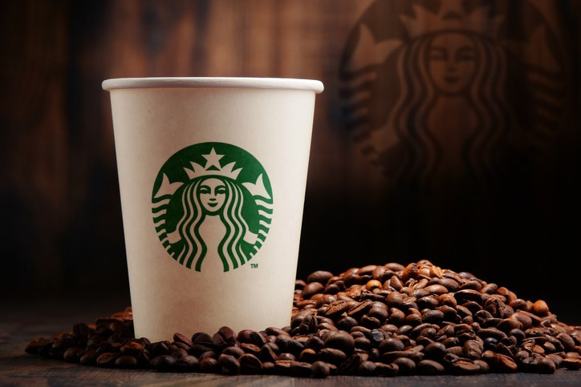

**Not only does Starbucks go through mounds of coffee beans to satiate its raving fans, but they also have mounds of data that they leverage in many ways to improve the customer experience and their business. With**[**90 million transactions a week**](https://digit.hbs.org/submission/starbucks-grinding-data/)**in 25,000 stores worldwide the coffee giant is in many ways on the cutting edge of using big data and artificial intelligence to help direct marketing, sales and business decisions.**

**Starbucks Rewards and Mobile App**

**When Starbucks launched its rewards program and mobile app, they dramatically increased the data they collected and could use to get to know their customers and extract info about purchasing habits. The mobile app has more than**[**17 million**](https://digit.hbs.org/submission/starbucks-grinding-data/)**and the reward program has 13 million active users. These users alone create an overwhelming amount of data about what, where and when they buy coffee and complementary products that can be overlaid on other data including weather, holidays and special promotions. Here are just some of the ways that Starbucks uses the data it collects.**

**Personalizing the Starbucks experience**

**Members of the rewards program and mobile app authorize Starbucks to gather a lot of info about their coffee-buying habits from their preferred drinks to what time of day they’re usually ordering. So, even when people visit a “new” Starbucks location, that store’s point-of-sale system is able to identify the customer through their smartphone and give the barista their preferred order. In addition, based on ordering preferences, the app will suggest new products (and treats) customers might be interested in trying. This intel is driven by the company’s**[**digital flywheel program**](https://www.zacks.com/stock/news/270022/starbucks-digital-flywheel-program-will-use-artificial-intelligence)**, a cloud-based artificial intelligence engine that’s able to recommend food and drink items to customers who didn’t even know, yet, they wanted to try something new. It’s so sophisticated that the recommendations will change based on what makes the most sense according to the day’s weather, if it’s a holiday or a weekday, and what location you’re at.**

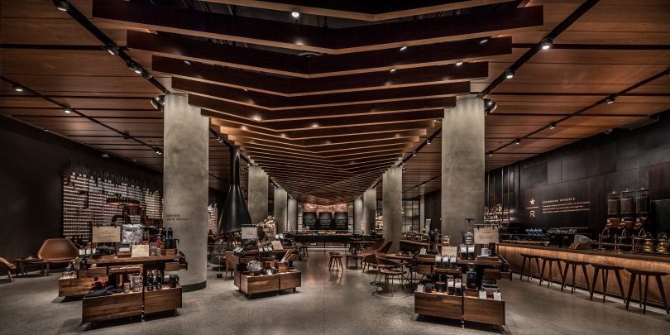

**Targeted and personalized marketing**

**The same intel that helps Starbucks suggest new products for to try also helps the company send personalized offers and discounts that go far beyond a special birthday discount. Additionally, a customized email goes out to any customer who hasn’t visited a Starbucks recently with enticing offers—built from that individual’s purchase history—to re-engage them.**

**Virtual barista**

**My Starbucks Barista through the Starbucks mobile app, allows you to place an order through voice command or messaging to a virtual barista using artificial intelligence algorithms behind the scenes. Since there are so many nuances to an individual order, it’s quite an accomplishment for an artificial intelligence engine to provide a seamless customer experience.**

**Determine new store locations**

**It’s common knowledge that the right location is essential to succeed in retail. The Starbucks market planning team doesn’t rely on their gut feelings to determine where stores should be located, but taps into the power of data intelligence through**[**Atlas, a mapping and business intelligence tool developed**](https://digit.hbs.org/submission/starbucks-grinding-data/)**by Esri. This tool evaluates massive amounts of data, such as proximity to other Starbucks locations, demographics, traffic patterns and more, before recommending a new store location. This system even predicts impact to other Starbucks locations in the area if a new store were to open. Even though it feels like there’s a Starbucks on every corner (and some so close to each other you might imagine that they would cannibalize sales from one another) rest assured the data told them to build it.**

**Expansion of products into grocery stores**

**When the company decided to expand and offer Starbucks products customers could purchase at grocery stores and enjoy at home, they turned to**[**data to determine what products they should offer**](https://www.cnbc.com/2016/04/06/big-data-starbucks-knows-how-you-like-your-coffee.html)**. It combined data it had from its stores about how customers ordered their beverages and combined that intelligence with other industry reports about at-home consumption to create their grocery store product lines. From pumpkin spice caffe latte K-cups to iced coffee without milk or added flavors, Starbucks’ data-driven approach to production expansion is smart business.**

**Menu updates**

**Some Starbucks locations serve alcohol, but the company decided which ones would offer “Starbucks Evenings” based on areas the data was signaling would have the highest alcohol consumption to support success of the menu update. Data also drives special limited-offering menu items based on what’s happening at the time. In one example, when Memphis, Tennessee was enduring a heatwave, Starbucks launched a local Frappucino promotion to entice people to beat the heat! And, although there are**[**87,000 drink combinations**](https://www.favrify.com/starbucks-drinks/)**available at Starbucks they continue to monitor what drinks sell the best to continue to make menu modifications.**

**So, next time you need your coffee fix, take a moment to appreciate all the ways data and artificial intelligence are at work behind the scenes guiding your Starbucks experience (and to keep you coming back for more!)**

